**Electric Circuit Experiments**

**02.Power Source Transformation and**

**Equivalent Power Source Theorem**

# Design a circuit to test the voltage-current relation of 1KΩ resistor.

A report by

**KIBRIA GOLAM**

**Student ID: 2019380163**

**Experiment principle:**

A source transformation is the process of replacing a voltage source

in series with a resistor by a current source is in parallel with a resistor, or vice versa.

The objective of this experiment is to prove that this source transformation indeed works. The equivalent resistance and short circuit current should be equal for the both circuit for the transformation to be proved.

**Circuit:**

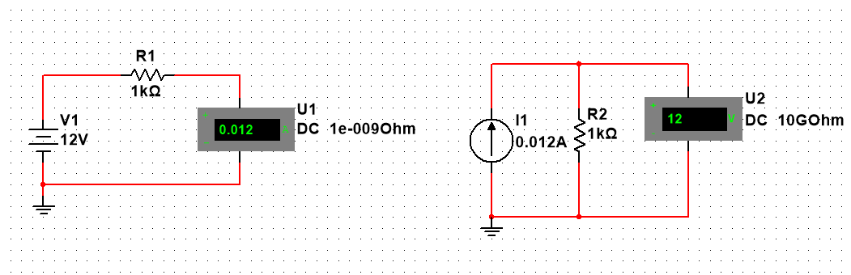

**Simulation Steps:**

1. A circuit with a 12V source in series with 1k-ohm resistor as the internal resistance of the voltage source is drawn in NI Multicim 14.0.
2. An ammeter is attached in series with the resistor to measure the short circuit current.
3. At the other side, another circuit is created with a current source (with the short circuit current value from the first circuit) in parallel with a 1k-ohm resistor.
4. A volt meter is attached in parallel with the resistor to measure the voltage.

**Simulation Data:**

|  |  |  |  |
| --- | --- | --- | --- |
| Source Type | Resistance | Current | Voltage |
| Voltage source(Left Ckt) | 1k-Ohm | Isc=Vs/R  =0.012A | 12V(Vs) |
| Current Source(Right Ckt) | 1k-Ohm | 0.012A(Is) | V= Isc  . R  =12V |

**Analysis and conclusion:**

From the simulation data table it is evident that the voltage and current both sources have the same equivalent resistance (1k-Ohm; if the sources are withdrawn; voltage source as short circuit and current source as open circuit) and the short circuit current for both circuit is equal (Isc = Is=0.012A ) which testifies the authenticity of the source transformation.